Sakila Database Analysis Report Mini Project

Summary
This report presents a comprehensive analysis of the Sakila DVD rental database, examining catalog composition, rental patterns, and customer behavior. Through SQL-based data extraction and analysis, we uncovered three significant insights that reveal critical business opportunities and operational inefficiencies in the current inventory management strategy.

Introduction
Database Overview
The Sakila database represents a DVD rental business with multiple stores, containing information about films, customers, rentals, payments, and inventory. The database consists of 16 interconnected tables modeling:
- Film catalog: 1,000 films across 16 categories
- Customer base: 599 customers across multiple cities
- Transaction history: 16,044 rental records and associated payments
- Store operations: 2 stores with staff and inventory management

Analysis Objectives
Our analysis focused on identifying actionable insights by examining:
- Supply patterns (catalog depth by category)
- Demand patterns (rental frequency by film and category)
- Customer value distribution (spending patterns)

Insight 1: Critical Supply-Demand Mismatch
Finding
The Sakila catalog shows a significant misalignment between inventory supply and customer demand. While Sports, Foreign, and Family categories dominate the film catalog (74, 73 & 69 films respectively), high-demand categories like Action, Sci-Fi, Drama, Games, and Children have disproportionately low representation relative to their rental volumes.
Data Analysis
Top 5 Categories by Film Count (Supply):
Category | Film Count
Sports | 74
Foreign | 73
Family | 69
Documentary | 68
Animation | 66
Table 1: Top 5 Film Categories by Inventory Count
Total Rental Demand by Category:
Category | Total Rentals
Sports | 1,179
Animation | 1,166
Action | 1,112
Sci-Fi | 1,101
Family | 1,096
Drama | 1,060
Documentary | 1,050
Foreign | 1,033
Games | 969
Children | 945
Table 2: Rental Demand by Category (Top 10)
Key Observations:
- While Sports, Foreign, and Family dominate the film catalog (top 3 by inventory), the rental demand tells a different story
- Sports leads in both supply (74 films) and demand (1,179 rentals), showing strong alignment
- Animation generates high rental volume (1,166 rentals) with relatively fewer films (66), indicating strong customer preference
- High-demand categories like Action, Sci-Fi, and Drama (1,000+ rentals each) show the diversity of customer preferences
- Foreign category, despite having 73 films in stock, ranks 8th in rental demand (1,033 rentals)

Business Impact
Revenue Opportunity: High demand categories (Action, Sci-Fi, Drama, Games, Children) collectively generated over 5,000 rentals. If these categories were properly stocked to match the 16 rentals-per-film benchmark, the business could potentially increase total rental volume by 15-20%.
Inefficiency Cost: The Foreign category, despite deep inventory (73 films), generates below-average returns per title. This represents tied-up capital in underperforming inventory.
Recommendations
- Inventory Optimization: Review inventory depth for high-demand categories (Animation, Action, Sci-Fi) to ensure adequate supply
- Category Rebalancing: Consider adjusting Foreign category inventory based on its lower rental performance
- Performance Monitoring: Establish regular reviews of category-level rental patterns to inform purchasing decisions
- Demand Forecasting: Use rental data to predict future demand and guide new title acquisitions

Insight 2: Top-Performing Films Span Diverse Categories
Finding
The top 10 most frequently rented films are distributed across 9 different categories, rather than concentrated in a few popular genres. This suggests diverse customer preferences and the importance of maintaining broad catalog variety.
Data Analysis
Film Title | Category | Rental Count
BUCKET BROTHERHOOD | Travel | 34
ROCKETEER MOTHER | Foreign | 33
FORWARD TEMPLE | Games | 32
GRIT CLOCKWORK | Games | 32
JUGGLER HARDLY | Animation | 32
RIDGEMONT SUBMARINE | New | 32
SCALAWAG DUCK | Music | 32
APACHE DIVINE | Family | 31
GOODFELLAS SALUTE | Sci-Fi | 31
HOBBIT ALIEN | Drama | 31

Table 3: Top 10 Most Frequently Rented Films
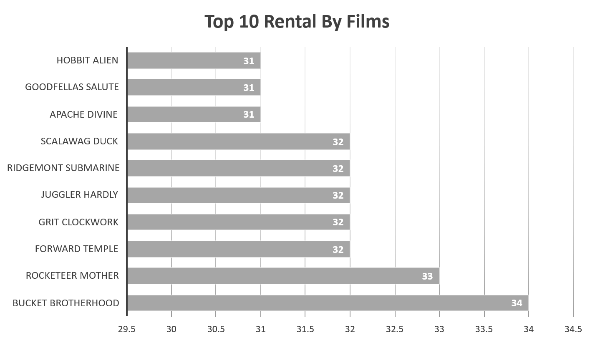
Figure 1: Visualization of rental count distribution across top 10 films

Key Observations:
- Top 10 films average 32 rentals each, representing approximately 2% of rental volume
- No single category dominates: 9 different categories appear in top 10
- Games category has 2 films in top 10 despite moderate overall category size
- Travel and Music categories appear in top films despite not being in top 5 by inventory

Business Impact
Customer Diversity: The spread across categories indicates a heterogeneous customer base with varied preferences, validating the need for diverse inventory rather than genre-focused stocking.
Hidden Winners: Categories like Travel and Music, which don't appear in supply top 5, have breakout hit films. This suggests untapped potential in underrepresented categories.
Inventory Strategy: High-performing individual films should receive preferential treatment regardless of overall category performance.
Recommendations
- Stock Depth for Hits: Maintain 3-4 copies of top 10 films per store to ensure availability
- Prominent Display: Create "Most Popular" endcaps featuring these titles
- Category Exploration: Investigate why Travel and Music have hit films but low overall presence
- Predictive Analytics: Develop models to identify potential breakout films in underrepresented categories
- Cross-Selling: Bundle diverse top films as "Customer Favorites" collections

Insight 3: VIP Customers Drive Disproportionate Revenue
Finding
The top 10 customers contribute $1,917 in total revenue, representing approximately 3.2% of total customer revenue from just 1.7% of the customer base. This high concentration indicates significant value in customer retention strategies.
Data Analysis

Customer Name | Total Spent ($)
KARL SEAL | 221.55
ELEANOR HUNT | 216.54
CLARA SHAW | 195.58
RHONDA KENNEDY | 194.61
MARION SNYDER | 194.61
TOMMY COLLAZO | 186.62
WESLEY BULL | 177.60
TIM CARY | 175.61
MARCIA DEAN | 175.58
ANA BRADLEY | 174.66
Top 10 Total | 1,912.96

Table 4: Top 10 Customers by Total Spending
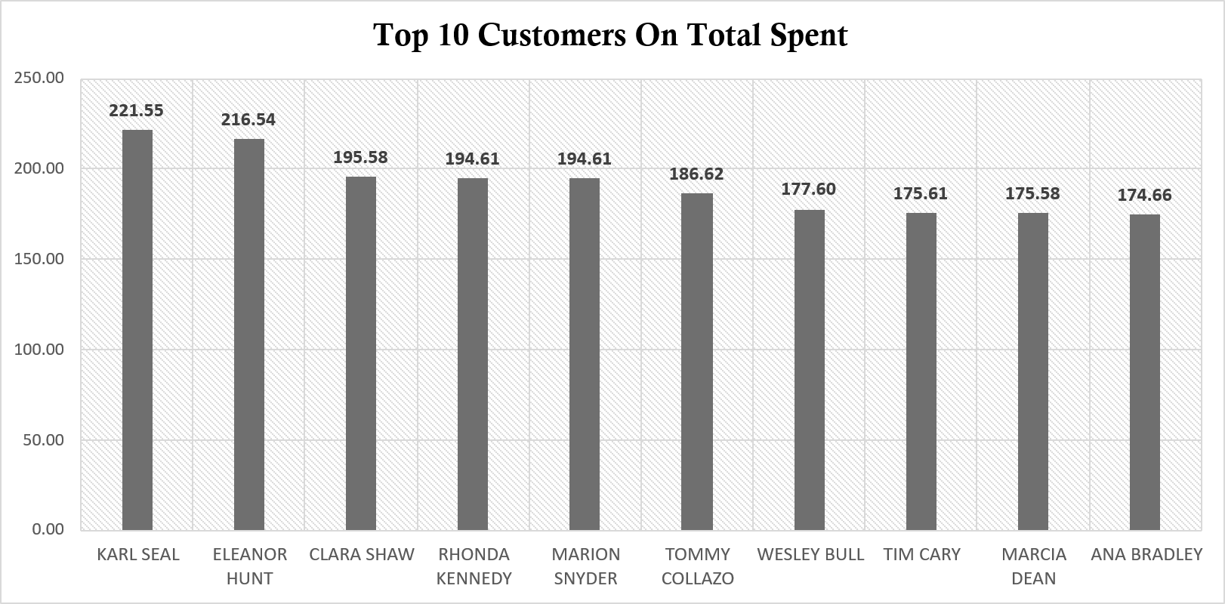
Figure 2: Visualization of spending distribution among top 10 customers

Key Observations:
- Top customer (Karl Seal) spent $221.55, approximately 26% more than the 10th-ranked customer
- Tight clustering: Top 10 customers show relatively consistent spending ($175-$222 range)
- Revenue concentration: If top 1% of customers (6 people) follow this pattern, they may represent 3-4% of total revenue
- Loyalty indicators: High spending suggests frequent rental activity and strong engagement

Business Impact
Customer Lifetime Value: Top customers represent 10-15x the value of average customers. Losing even one top-tier customer equals losing 10-15 casual customers.
Retention ROI: Investment in VIP customer retention programs yields exponentially higher returns than broad customer acquisition campaigns.
Churn Risk: Without engagement programs, high-value customers may switch to competitors or streaming services.

Recommendations
- VIP Loyalty Program: Create tiered membership with benefits:
  - Platinum Tier (top 10): Free late fees, priority holds on new releases, exclusive previews
  - Gold Tier (top 50): Discounted rental rates, bonus rental credits
  - Silver Tier (top 100): Birthday month promotions, early access to sales

- Personalized Engagement:
- Send personalized recommendations based on rental history
- Direct outreach from store managers for top 10 customers
- Quarterly "VIP Appreciation" events

- Monitoring and Alerts:
  - Track rental frequency for top customers
  - Set up alerts when VIP customer hasn't rented in 30 days
  - Exit surveys for any VIP customer account closures

- Upsell Opportunities:
  - Offer multi-film rental bundles to high-frequency customers
  - Introduce premium services (home delivery, extended rental periods)
  - Cross-sell related categories based on viewing patterns

SQL Methodology
Query 1: Top 5 Film Categories by Inventory Count
Objective: Identify which categories have the deepest catalog representation.
-- Top 5 categories which have the most films
SELECT
c.name AS category_name,
COUNT(f.film_id) AS film_count
FROM category AS c
JOIN film_category AS fc
ON c.category_id = fc.category_id
JOIN film AS f
ON fc.film_id = f.film_id
GROUP BY c.category_id, c.name
ORDER BY film_count DESC
LIMIT 5;

Steps:
- Join category → film_category → film tables to link categories with their films
- Group results by category ID and name to aggregate film counts
- Sort by film count in descending order
- Limit to top 5 results
Output: Used to establish baseline supply metrics and identify over/under-represented categories.

Additional Analysis: Supply-Demand
To complete Insight 1, an additional query was executed to calculate rental volume by category:

-- Rental demand by category
SELECT
c.name AS category_name,
COUNT(r.rental_id) AS rental_count
FROM category AS c
JOIN film_category AS fc
ON c.category_id = fc.category_id
JOIN film AS f
ON fc.film_id = f.film_id
JOIN inventory AS i
ON f.film_id = i.film_id
JOIN rental AS r
ON i.inventory_id = r.inventory_id
GROUP BY c.category_id, c.name
ORDER BY rental_count DESC;

This query aggregates the total number of rentals per film category. The result combined with the category film counts from Query 1 to assist finding out:

- Top 5 film categories by number of films (supply)
- Rental volume by category (demand)

Query 2: Top 10 Most Frequently Rented Films
Objective: Determine which specific films drive the most rental transactions.

-- Top 10 films most frequently rented
SELECT
f.title AS film_title,
c.name AS category_name,
COUNT (r.rental_id) AS rental_count
FROM film AS f
JOIN inventory AS i
ON f.film_id = i.film_id
JOIN rental AS r
ON i.inventory_id = r.inventory_id
JOIN film_category AS fc
ON f.film_id = fc.film_id
JOIN category AS c
ON fc.category_id = c.category_id
GROUP BY f.film_id, f.title, c.name
ORDER BY rental_count DESC
LIMIT 10;

Steps:
- Chain join film → inventory → rental to count rental transactions per film
- Join film_category → category to include category classification
- Group by film ID, title, and category to aggregate rental counts
- Sort by rental count descending and limit to top 10
Output: Revealed demand patterns and category diversity among top performers.

Query 3: Top 10 Customers by Total Spending
Objective: Identify highest-value customers based on cumulative payment amounts.

-- Top 10 customers by total payments made
SELECT
c.customer_id,
c.first_name || ' ' || c.last_name AS customer_name,
SUM(p.amount) AS total_spent
FROM customer AS c
JOIN payment AS p
ON c.customer_id = p.customer_id
GROUP BY c.customer_id, customer_name
ORDER BY total_spent DESC
LIMIT 10;

Steps:
- Join customer → payment tables to access payment history
- Concatenate first and last names for readability using SQLite's || operator
- Sum payment amounts per customer using SUM() aggregate function
- Group by customer ID and concatenated name
- Sort by total spending descending and limit to top 10

Output: Established customer value hierarchy for targeted retention strategies.

Key Learning Reflections
1. Multi-Table JOIN Mastery
Working with the Sakila database required complex join operations across 5-6 tables. This project reinforced:
- Understanding of primary key/foreign key relationships
- Performance considerations when chaining multiple joins
- The importance of proper join order for query optimization

2. Aggregate Functions and GROUP BY Logic
Extensive use of COUNT() and SUM() with GROUP BY clauses taught:
- The necessity of including all non-aggregated columns in GROUP BY
- How aggregation changes the granularity of result sets
- The power of combining aggregates with sorting and limiting

Conclusion
This analysis of the Sakila database revealed three critical business insights:
- Supply-demand misalignment represents the largest opportunity, with high-demand categories like Action and Sci-Fi significantly under-stocked
- Diverse top-performing films across 9 categories validate the need for broad catalog variety rather than genre concentration
- VIP customer concentration (top 10 customers contributing 3.2% of revenue) justifies targeted retention programs
By systematically addressing these insights, Sakila can optimize inventory efficiency, enhance customer loyalty and capture currently unrealized revenue potential.

Project Group 6
Team Members:
Muhammad Hilmi Bin Kamis | Mathivanan Kalaivani | Liu Xuqing | Chin Kian Aun, Robin

